**Level 1: Start of Game - Input / Output Analysis**

1. For Simon game you press one button & then you press all four buttons to start off playing the game. If you press the yellow button shows you your high score. If you press the green you can play multiplayer, blue button starts off the game, red button plays the song if you beat the game.
2. A) If the game is on then make sure you must turn if off, if the game shows your high score then you make sure it goes back to the menu when you over with, if the user presses the green button then it shows that you can play multiplayer.

|  |  |  |
| --- | --- | --- |
| **Object** | **Action** | **Result** |
| Red button | Push | Tells you, you have beat the game. |
| Yellow button | Push | Yellow button tells you what your high score. |
| Green button | Push | Green button tells you if you want to play single player or multiplayer. |
| Blue button | Push | Blue button helps you start off the game. |

|  |  |  |
| --- | --- | --- |
| **Object** | **Action** | **Meaning** |
| Red button | Plays Tone & Light | The sound would light up and it would show a pattern. |
| Yellow button | Plays Tone & Light | The sound would light up and it would show a pattern. |
| Green button | Plays Tone & Light | The sound would light up and it would show a pattern. |
| Blue button | Plays Tone & Light | The sound would light up and it would show a pattern. |

**Level 2: Game Play - Input / Output Analysis**

1. First you press the red and then you start off playing in the order. Then you press the green button it shows off your high score what it is, there are options to go back to the menu. After that you go to the yellow button and you press it to find out if you can play as single player or multiplayer.
2. If you play the game and you press the wrong button, then you have restart the game over and then it will play that annoying sound again.
3. If you press the all the button and you make it threw that pattern, then it plays a sound which means you have won the game and you have beaten that level.
4. If you press a button and the game is going on, & suddenly you don’t follow the pattern your press the wrong button the you will lose the game.

**Level 3: Flowchart Conventions**

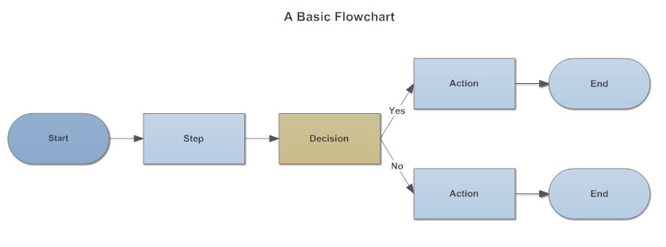

**Input/Output**: There are 3 digital pins that can be changed with PinMode(), you can change editing the program.

**Process/Annotation:**

**Online Storage:** It storage data online ,maybe on a hard drive.

**Offline Storage:** Local storage that is storing data somewhere else.

**Document:** Examples are receiving documents, reports or email.

**Display:** Used to indicate what information can be displayed on a process flow.

**Manual Input:** Represents the manual input, like using a keyboard to import data.

**Manual Operation:** Indicate a step that has to be done manually, rather than automatically.

**Preparation:** Differentiates between steps that prepare for work and steps that actually need to be done for work.

**Connector:** Usually uses complex charts, this symbol connects separate elements across the page.

1. The chart uses to same symbols ()Action and ()End.

**Level 4: Flowchart of the Simon Game**

